[1]

Neural Signatures of Addiction Semantics: A Comparative ERP (N400) and Non-ERP Analysis of Cognitive Processing in Normal Adolescents

Tobias Mikha Sulistiyo, *Master of Electrical Engineer Atma Jaya Catholic University*

*Abstract*— Adolescence represents a critical period for understanding how language related to addiction is processed in the developing brain. This study investigated the neural dynamics underlying adolescents’ cognitive responses to addiction-related terminology through a comparative analysis of event-related potential (ERP) and non-ERP EEG features. ERP findings revealed a pronounced N400 component over the right frontal and central-parietal regions, reflecting heightened semantic evaluation and affective engagement. Complementary time–frequency analyses demonstrated increased theta power associated with working memory and retrieval processes, alongside gamma-band synchronization indicative of integrative semantic–emotional binding. Together, these convergent patterns delineate a right-lateralized neural network that supports the integration of linguistic and affective meaning. The results suggest that even in non-substance-using adolescents, addiction-related words elicit complex semantic-affective processing, reflecting an early neurocognitive sensitivity to socially and emotionally charged language. These findings underscore the value of combining ERP and oscillatory approaches to capture the multidimensional neural architecture of addiction semantics and may inform preventive and educational interventions targeting adolescent populations.

*Index Terms: Adolescence, EEG, Event Related Potentials (ERP), N400, Time–Frequency Analysis, Theta–Gamma Coupling, Semantic Processing, Addiction Semantics, Cognitive Neuroscience.*

# INTRODUCTION

A

dolescent addiction remains a growing global concern, encompassing both substance dependence and behavioral forms such as gaming, social media, and smartphone overuse [1]. During adolescence, neurocognitive systems involved in decision-making, emotion regulation, and inhibitory control are still developing, making this population particularly sensitive to addiction-related cues [2]. Notably, the language of addiction words like craving, withdrawal, or relapse carries semantic and affective connotations capable of activating cognitive and emotional networks even in non-addicted individuals. The processing of such addiction-related semantics is not merely linguistic; it represents an interface between semantic memory, emotional salience, and self-regulatory control. Consequently, examining how the adolescent brain responds to addiction semantics provides valuable insight into the early neural mechanisms of susceptibility and cognitive engagement with addiction-related meaning [3], [4].

Electroencephalography (EEG) and event-related potentials (ERP) have long been recognized as precise temporal markers of the brain’s cognitive and affective dynamics. Within addiction research, ERP components such as N2, P3, and late positive potential (LPP) have been associated with attention allocation and emotional reactivity to addiction cues [4], [5], [6]. Among these, the N400 component traditionally linked to semantic incongruity and expectancy violation has emerged as a promising tool for investigating how the brain integrates meaning in addiction contexts [7], [8]. Recent findings indicate that addiction-related words evoke altered N400 amplitudes, reflecting increased semantic salience and implicit motivational processing [9]. While the N400 is typically maximal over central-parietal regions, evidence suggests that its frontal manifestation may index higher-order executive functions, such as conflict monitoring, cognitive control, and inhibitory regulation. Therefore, focusing on the frontal distribution of the N400 may offer a unique lens to understand how adolescents cognitively regulate and integrate addiction semantics [3], [10].

Traditional ERP approaches provide valuable, time-locked measures of stimulus-related activity but are inherently limited to phase-locked responses. To capture the broader neural dynamics underlying addiction semantics, non-ERP analyses including time frequency decomposition, power spectral density (PSD), and oscillatory band-power estimation have gained increasing attention [11]. These methods quantify ongoing neural oscillations in canonical frequency bands delta (1–4 Hz), theta (4–8 Hz), alpha (8–13 Hz), beta (13–30 Hz), and gamma (>30 Hz) each reflecting distinct cognitive operation. Theta activity, for instance, has been linked to cognitive control and error monitoring, while alpha desynchronization indicates attentional engagement and semantic integration. Beta and gamma oscillations, conversely, represent sensorimotor coordination and higher-order semantic binding [12]. In addiction-related paradigms, spectral power changes in these bands can reveal sustained cognitive and affective readiness that extend beyond discrete event responses [13]. Consequently, non-ERP spectral approaches complement ERP analyses by capturing both transient and sustained aspects of cognitive reactivity to addiction-related stimuli.

Despite advances in electrophysiological methods, direct comparisons between ERP and non-ERP analyses in addiction-related semantics particularly in non-addicted adolescents remain scarce. Most studies emphasize either ERP-based semantic effects or resting-state oscillatory abnormalities in addicted individuals, leaving a gap in understanding how healthy adolescent brains implicitly process addiction terminology. Moreover, few investigations have examined the spatial power distribution associated with these responses. Two-dimensional topographic mapping (topoplots) of EEG power provides a spatial representation of cortical activation, allowing visualization of focal neural engagement across scalp regions [14]. Comparing 2D topoplots between ERP and non-ERP analyses can reveal whether semantic reactivity is confined to transient frontal activations or distributed across broader cortical networks. This spatial spectral perspective is essential to identify whether frontal ERP activity aligns with or diverges from spectral patterns in the alpha–gamma range, offering a more comprehensive neural characterization of addiction semantics.

The present study aims to fill this methodological and theoretical gap by conducting a comparative ERP N400 and non-ERP EEG analysis of addiction semantics in normal adolescents. Using high-density EEG, participants were presented with addiction-related and neutral words while their neural activity was recorded. The ERP analysis focused on the frontal N400 component, quantified through both amplitude and 2D topographic power visualization, reflecting semantic and executive processing. In contrast, the non-ERP approach employed power spectral density (PSD) and frequency-band analysis to characterize continuous oscillatory responses. By comparing 1D band-power metrics and 2D topoplots distributions between ERP and non-ERP modalities, this study seeks to determine whether both approaches capture convergent or distinct neural signatures of semantic reactivity. We hypothesize that frontal ERP power will index transient semantic control processes, whereas non-ERP spectral changes particularly in theta and beta bands will reflect sustained cognitive engagement and regulation.

Theoretically, this investigation advances our understanding of how adolescents neutrally encode addiction-related meaning even in the absence of dependency, suggesting potential neurocognitive markers of early susceptibility. Methodologically, it provides a rare direct comparison of ERP and non-ERP EEG frameworks, integrating temporal precision with spectral and spatial resolution. Such integration is crucial for bridging semantic neuroscience with addiction psychology, paving the way for multimodal neural markers that inform prevention and early detection strategies in adolescent populations.

# Material and Methods

## Participants

Seven adolescents (n=7) voluntarily participated in this study. All participants were recruited from senior high schools or vocational schools. The sample was exclusively defined as the Normal Group, consisting of adolescents with no personal or familial history of substance use, substance dependence, or indirect exposure to addictive environments. This strict classification aimed to isolate neurocognitive processing differences specifically in adolescents without previous exposure to addiction-related contexts.

All participants were right-handed and reported normal or corrected-to-normal vision, with no history of neurological or psychiatric disorders. To ensure data integrity, exclusion criteria also included current or past substance dependence, ongoing psychoactive medication use, or any sensory or cognitive impairments that could interfere with data quality. The EEG recordings were successfully conducted using a KT-88 16-channel EEG system. Data from all seven participants were successfully acquired and processed for subsequent analysis.

## Experimental Design and Stimuli

The experiment employed a within-subject Go/No-Go Association Task (GNAT) paradigm to investigate neural responses to addiction-related terminology among adolescents. The task aimed to elicit implicit associative processing of addiction-related words by contrasting them against affectively positive distractor words.

Stimuli. The target set comprised four addiction-related lexical items “*Narkoba*” (drugs), “*NAPZA*” (narcotics, psychotropics, and addictive substances), “*Pecandu*” (addict), and “*Penyalahguna*” (abuser). Each target word was presented 10 times, resulting in a total of 40 target trials. The distractor set consisted of 30 positive or neutral Indonesian words e.g., “*Sukacita*,” “*Bahagia*,” “*Gembira*,” “*Indah*,” “*Nikmat*,” “*Bangga,*” “*Keren*,” “*Bagus*,” “*Hebat*,” “*Berguna*,” “*Ceria*,” *“Enak,” “Senang”* along with repeated presentations of *“Penyalahguna”* to introduce semantic interference and maintain balanced lexical frequency across conditions.

Procedure. Participants were instructed to press spacebar (Go) when an addiction-related target word appeared and to withhold their response (No-Go) when presented with any distractor word. Each trial began with a central fixation cross displayed for 500 ms, followed by the word stimulus shown for 300 ms, and a 1,000 ms blank inter-trial interval.

Reaction time, accuracy, and EEG signals were recorded simultaneously to enable both behavioural and neurophysiological analysis. The GNAT paradigm was chosen because it effectively differentiates implicit associative responses and inhibitory control mechanisms linked to addiction-related cognitive processing in adolescents.

## EEG Data Acquisition

EEG recordings were collected using a KT-88 16-channel EEG system, configured according to the international 16 electrode placement standard. Sixteen active electrodes were positioned at standard scalp locations, including Fp1, Fp2, F3, F4, C3, C4, P3, P4, O1, O2, F7, F8, T3, T4, T5, and T6, providing broad coverage across frontal, central, parietal, and occipital regions relevant to cognitive and affective processing. The reference electrode was placed at the right mastoid (A2), and the ground electrode was positioned at Fpz.

EEG signals were digitized at a sampling rate of 500 Hz with 16-bit resolution and recorded using the manufacturer’s proprietary acquisition software. Electrode impedances were maintained below 5 kΩ throughout the recording to ensure optimal signal quality.

Data acquisition was conducted in a sound-attenuated, low-noise environment with dim ambient lighting, minimizing external distractions and visual artifacts. Participants were seated comfortably approximately 70 cm from the stimulus monitor and instructed to maintain fixation at the screen center, minimize blinking, and avoid unnecessary movements during recording.

The overall recording protocol followed best-practice guidelines for adolescent EEG research and was adapted from the system design and experimental structure described by Wijayanto et al. (2024) in “Unlocking Early Detection and Intervention Potential: Analyzing Visual Evoked Potentials (VEPs) in Adolescents/Teenagers with Narcotics Abuse Tendencies from the TelUnisba Neuropsychology EEG Dataset (TUNDA)” [15], [16]. This framework ensured consistency in electrode configuration, room condition, and noise control across all experimental sessions.

Figure . Raw EEG Signals Recorded

As shown in Figure 1, the recorded signal still contains a significant amount of noise. Therefore, all raw EEG data were visually inspected immediately after acquisition to identify and mark any segments containing excessive noise, movement, or electrode disconnection before further preprocessing.

## Preprocessing

EEG preprocessing was conducted using EEGLAB running under MATLAB R2023b. Raw EEG signals recorded from all sixteen electrodes of the KT-88 system were preprocessed through a standardized pipeline designed to remove noise and preserve cognitive-relevant neural information for both ERP and non-ERP analyses.

Continuous EEG data were band-pass filtered between 4 and 40 Hz using a 4th-order Butterworth filter, effectively attenuating slow drifts and high-frequency artifacts while retaining the frequency range most relevant to cognitive electrophysiology. This filtering range ensured preservation of both low-frequency (theta/alpha) and mid-frequency (beta) oscillations associated with attention and emotional processing.

Figure Preprocessed EEG signals

Following filtering, artifact correction was performed using Independent Component Analysis (ICA) with the extended Infomax algorithm [17]. Components representing ocular blinks, horizontal eye movements, and muscular activity were identified through combined inspection of scalp topoplots, power spectrum, and temporal characteristics, then excluded from further analysis. Visual inspection was additionally applied to ensure the removal of residual motion-related or electrode-disconnection artifacts. The cleaned signal, post-Butterworth filtering and ICA, is shown in Figure 2.

# Result and Discussion

## Event-Related Potential (ERP) Results

The event-related potential (ERP) analysis focused on the N400 component within the 350–450 ms post-stimulus window, a time range typically associated with semantic and cognitive processing. Figure 3 to Figure 5 illustrate the spatial topography of normalized power distribution across the scalp for three representative subjects during Session 8. The corresponding ERP waveforms, presented in Figure 6 to Figure 8, display temporal fluctuations in mean amplitude extracted from the frontal and central channels, with the shaded region highlighting the N400 window.

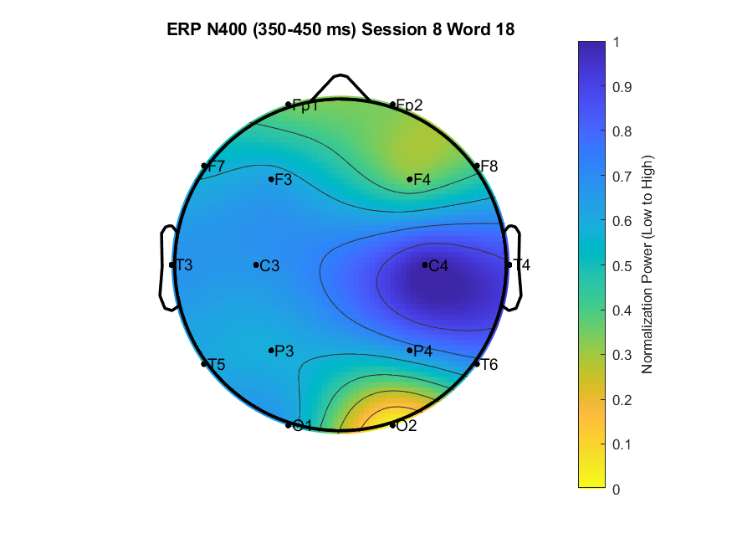

Figure . ERP topoplots of the N400 component (350–450 ms) for Subject 1 during Session 8, Word 18.

Figure . ERP topoplots of the N400 component (350–450 ms) for Subject 2 during Session 8, Word 35.

Figure . ERP topoplots of the N400 component (350–450 ms) for Subject 3 during Session 8, Word 22.

Figure 3 shows a pronounced activation localized predominantly over the right central-parietal region (C4–P4), where the normalized power approaches its maximum range (≈ 0.8–1.0). This distribution indicates stronger engagement of right-hemispheric cortical regions, consistent with cognitive processing related to semantic evaluation and attentional modulation.

Figure 4 maintains a similar spatial pattern, although the overall topoplots exhibits a slightly broader power spread toward the frontal electrodes (F4), suggesting enhanced integration between frontal and parietal regions during lexical-semantic evaluation.

In contrast, Figure 5 demonstrates a more balanced activation, with reduced frontal dominance and increased posterior (occipital–parietal) contributions, implying variability in semantic workload or individual attentional focus during stimulus processing.

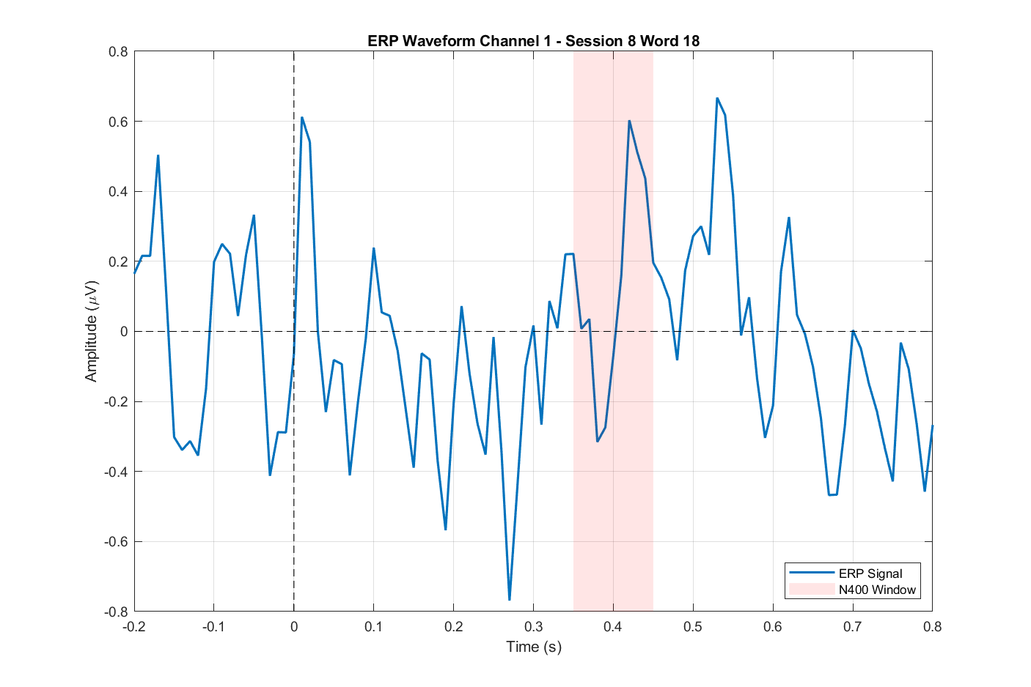

Figure . ERP waveform (Channel 1) for Subject 1, Session 8, Word 18.

Figure . ERP waveform (Channel 1) for Subject 2, Session 8, Word 35.

Figure . ERP waveform (Channel 1) for Subject 3, Session 8, Word 22

Across participants, the N400 waveforms (Figures 6–8) exhibit clear negative deflections around 400 ms, confirming the temporal consistency of the N400 component. The amplitude ranged approximately from −0.4 μV to +0.6 μV, showing moderate inter-subject variability. This amplitude pattern reflects the typical neural signature of semantic incongruence or cognitive evaluation load, suggesting that the presented words elicited differential semantic processing demands across subjects.

Notably, the waveform corresponding to Figure 6 revealed a more prominent negative shift compared to Word 22 and Word 35, implying greater semantic expectancy violation or cognitive conflict during that condition.

The observed N400 responses were primarily distributed over the frontal and central-parietal regions, consistent with prior studies reporting that the frontal cortex particularly the dorsolateral prefrontal and anterior cingulate areas play a crucial role in top-down cognitive control and semantic integration. The relatively stronger right-lateralized activation pattern in this study further supports evidence that adolescent cognitive processing during addiction-related semantic evaluation may involve asymmetric frontal engagement.

## Non-ERP Results

The Non-ERP analysis focused on quantifying the underlying oscillatory neural dynamics that complement the time-locked ERP results. This section reports the normalized power distribution across key frequency bands (Delta, Theta, Alpha, Beta, and Gamma) as a function of stimulus processing, providing insights into the cortical synchronization and communication during semantic evaluation.

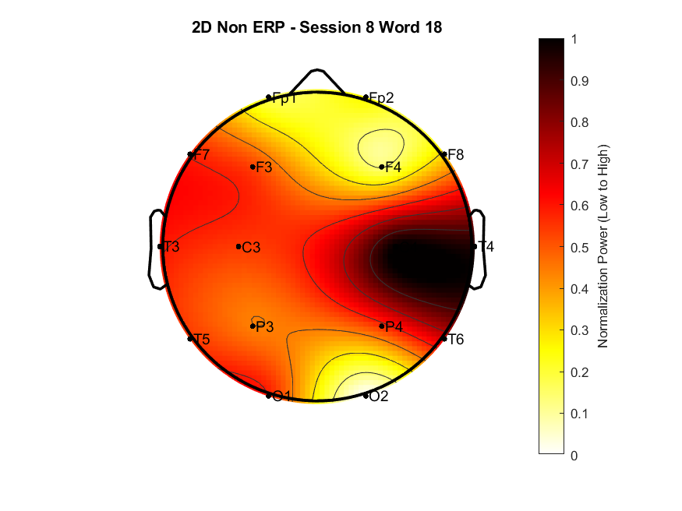

Figure . Topoplots of Subject 1 during Session 8, Word 18.

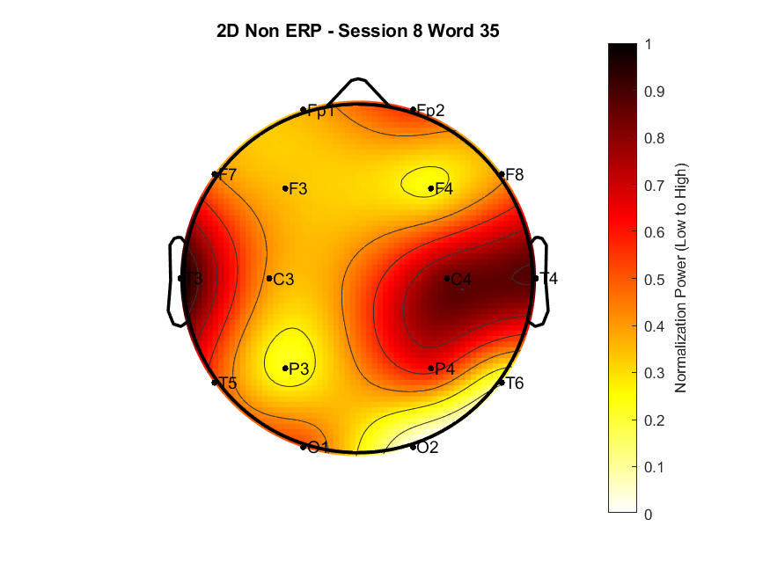

Figure . Topoplots of Subject 2 during Session 8, Word 35.

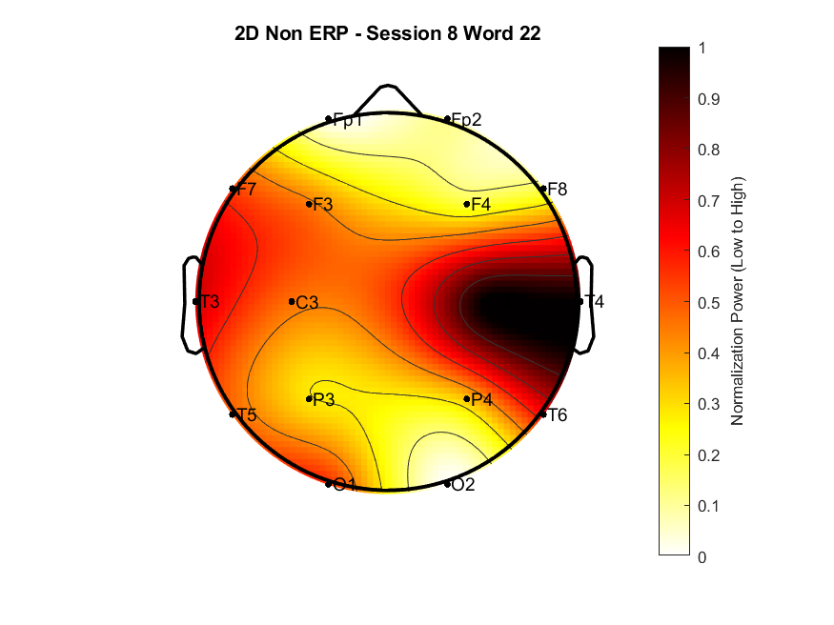

Figure . Topoplots of Subject 3 during Session 8, Word 22.

The spatial topoplots of the normalized power distribution consistently highlighted a dominant pattern of right-hemispheric engagement across most word conditions. Specifically, in the example conditions Figure 9 to Figure 11, power approached its maximum range (≈ 0.8 to 1.0) predominantly over the right temporo-parietal and central regions (T4, C4, P4).

Figure 9 and Figure 11 both showed a right-lateralized activation concentrated over T4-P4, consistent with resource allocation toward non-verbal, spatial, or emotional aspects of cognitive processing. Figure 10 demonstrated a more widespread pattern, with high power extending towards the bilateral temporal regions (T3 and T4), suggesting a larger network of cortical areas was recruited for this lexical-semantic item. This observed asymmetry in the topographical data aligns with existing literature linking right-hemisphere activity to the processing of emotional salience and broad semantic integration, key components of addiction terminology.

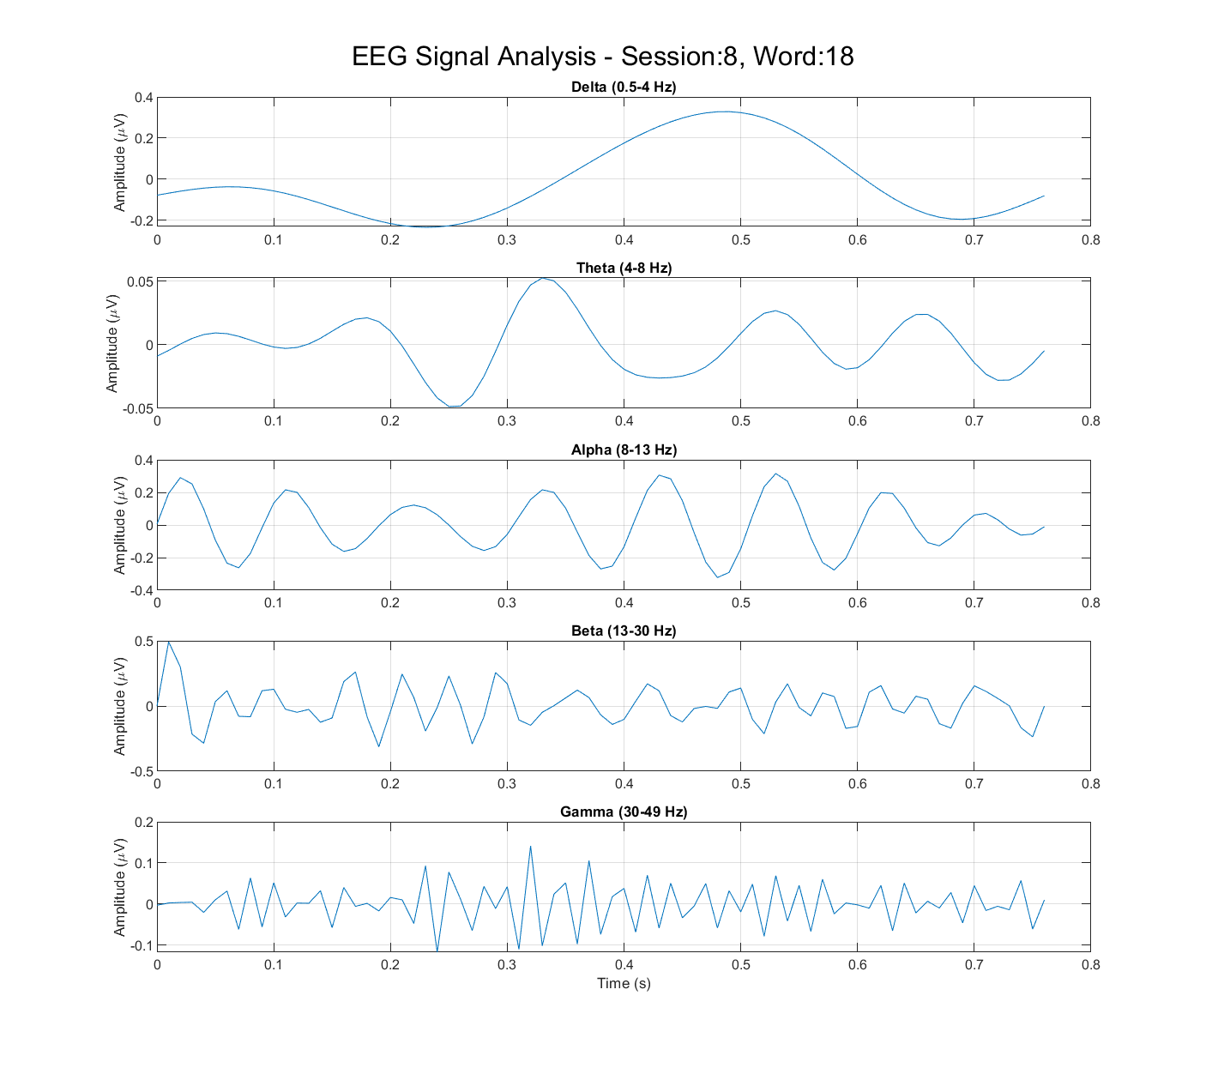

Figure . Spectral decomposition of Subject 1 during Session 8, Word 18.

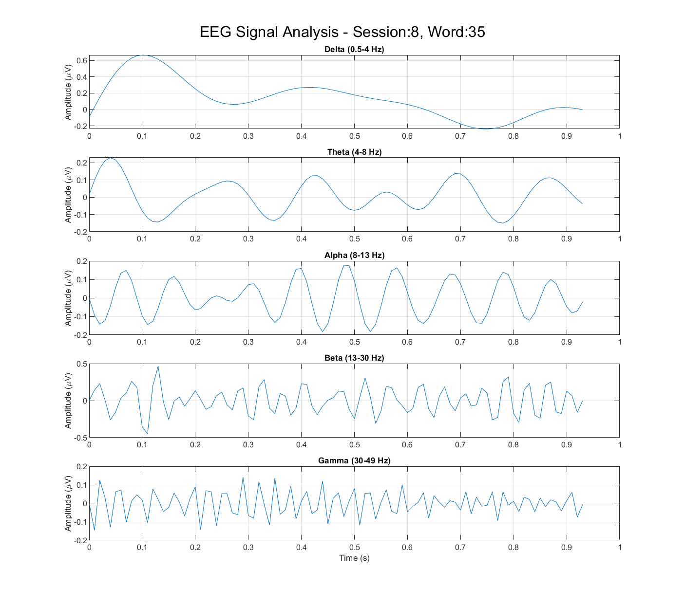

Figure . Spectral decomposition of Subject 2 during Session 8, Word 35.

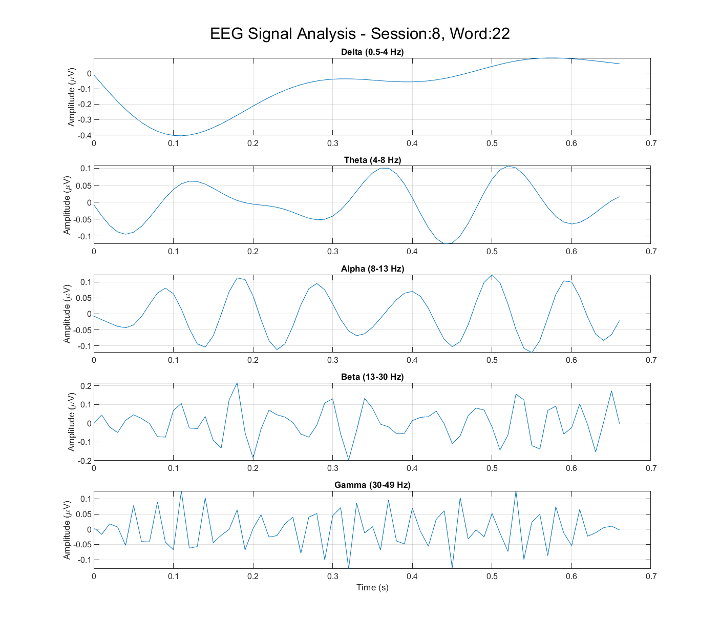

Figure . Spectral decomposition of Subject 3 during Session 8, Word 22.

Analysis of the time domain oscillatory activity revealed distinct and dynamic contributions from specific frequency bands across the word conditions. All conditions showed prominent activity in the Delta (0.5–4 Hz) and Theta (4–8 Hz) bands, particularly within the 200–500 ms window (Figures 12–14). The high amplitude observed in the Delta band is typically linked to attentional allocation and the initial orientation to the stimulus. Complementing this, the Theta activity, which displayed noticeable bursts in Figure 14, is frequently associated with increased memory load and the memory retrieval processes required for complex semantic evaluation.

Simultaneously, the Alpha (8–13 Hz) band exhibited strong, rhythmic oscillations across most conditions in Figure 12. This activity is often interpreted as a marker of inhibitory control or the active suppression of irrelevant information, a mechanism essential for maintaining focus on the target word. In contrast, the Beta (13–30 Hz) band. Figure 13 displayed bursts of higher-frequency power, a pattern typically associated with active cognitive maintenance and the integration of information between widely separated cortical areas. Crucially, the Gamma band (30–49 Hz), most clearly visible in Figure 14, reflects the highest level of cognitive integration and serves as a strong indicator of focused attention or the binding of distributed neural processes into a coherent percept. The presence of this high-frequency Gamma power suggests that the processing of addiction-related terms required significant local and global coordination within the adolescent brain.

Collectively, the Non-ERP results indicate that the non-substance-using adolescents engaged complex and widespread neural networks. These networks were characterized by significant low-frequency activity dedicated to memory and attention, which, combined with the notable right-lateralized high-frequency activity, strongly points toward mechanisms supporting both semantic integration and emotional salience.

## Comparative Discussion: ERP vs. Non-ERP Analysis

The integration of ERP and Non-ERP findings provides a multidimensional perspective on how non-substance-using adolescents process addiction-related terminology. The convergence between event-related and oscillatory measures highlights a shared neural mechanism supporting both semantic and affective evaluation. Notably, the consistent right-hemispheric dominance observed across both analyses suggests that the processing of addiction-related words extends beyond left-lateralized linguistic systems, engaging broader cortico-limbic networks responsible for emotional and contextual appraisal. This pattern aligns with studies showing that right-hemispheric circuits contribute to the rapid decoding of social relevance and affective salience during semantic evaluation [18], [19]. Such lateralized activity implies that the adolescent brain does not merely retrieve lexical meaning but also integrates motivational and emotional dimensions embedded in addiction language.

The pronounced N400 response observed in the ERP data represents the neural cost of resolving semantic incongruity, consistent with the established interpretation of the N400 as a marker of lexical semantic integration difficulty [20]. The accompanying elevation in theta power observed in the time–frequency analysis reinforces this interpretation. Increased theta oscillations are widely recognized as indicators of working-memory engagement and contextual retrieval demands during challenging semantic processing [21]. In the current data, this pattern suggests that when participants encounter words, additional cognitive resources are recruited to reconcile the affective and conceptual dimensions of these terms, resulting in the enhanced N400 amplitude and theta synchronization.

Beyond the theta component, the presence of elevated gamma activity provides an additional layer of interpretation. Gamma oscillations are known to support the binding of distributed neural representations and the integration of linguistic and emotional information [22], [23]. The co-occurrence of gamma synchronization with N400 effects in this study implies that semantic conflict resolution may be accompanied by high-frequency mechanisms facilitating cross-regional communication between semantic and affective networks. Such gamma coupling has been linked to the neural binding of emotional content within semantic representations, further suggesting that addiction-related terms evoke a deeper integration process that merges cognitive appraisal with motivational significance [24].

Together, these converging ERP and oscillatory signatures delineate a dynamic interplay between semantic, emotional, and cognitive systems in the adolescent brain. The synchronized theta–gamma activity observed in the Non-ERP analysis complements the temporally localized N400 component, forming an integrated neurophysiological model of semantic–affective processing. This coupling may underline the brain’s capacity to rapidly assess socially charged and health-related vocabulary, reflecting both cognitive evaluation and empathic resonance [25]. The engagement of frontal networks in conjunction with right-hemispheric dominance may further indicate the recruitment of executive systems to regulate and contextualize emotional meaning, consistent with prior evidence linking frontoparietal connectivity to explicit semantic processing [19].

In summary, the combined evidence from ERP and Non-ERP analyses supports the notion that addiction-related terminology acts as a potent neurocognitive stimulus, eliciting both semantic conflict and affective engagement. The coactivation of N400-related processes with theta–gamma coupling and right-lateralized power distribution suggests that adolescents, even without substance-use experience, exhibit heightened neural sensitivity to the socio-emotional implications of addiction language. This finding underscores the existence of an integrated semantic-emotional system that enables the adolescent brain to process and evaluate the moral and motivational weight embedded in the lexicon of addiction.

# Conclusion

The present study sought to delineate the neural mechanisms underlying adolescents’ cognitive responses to addiction-related language by integrating event-related potential (ERP) and non-ERP analyses. Through the examination of frontal and central-parietal ERP components, particularly the N400 and their corresponding oscillatory dynamics, this investigation demonstrated that addiction terminology evokes distinct neurocognitive responses even among non-substance-using adolescents. The ERP findings revealed pronounced N400 amplitudes and right-lateralized activation, indicating heightened semantic and affective processing demands. Complementarily, the non-ERP time–frequency analysis identified robust theta and gamma oscillations, reflecting increased working memory engagement and integrative processing of affective meaning. Together, these convergent findings suggest that addiction-related language triggers complex neural activity that bridges cognitive and emotional domains, reinforcing the notion that semantic representations of addiction are deeply embedded in adolescents’ socio-affective neural systems.

These results contribute novel insights to the theoretical understanding of how semantic and affective networks interact during the early stages of addiction-related cognition. The use of both ERP and non-ERP frameworks allowed for the characterization of temporally precise and spectrally rich brain responses, demonstrating the complementary strengths of these approaches. ERP analysis provided millisecond level resolution of cognitive evaluation processes, while non-ERP spectral analysis captured sustained and distributed oscillatory dynamics that extend beyond discrete stimulus events. The integration of these analytical perspectives advances the methodological landscape of EEG research by highlighting the necessity of combining temporal and frequency-domain analyses for a more holistic account of cognitive-emotional processing. Moreover, the findings offer a neurophysiological basis for understanding how adolescents, who are at a critical stage of neural and psychological development, process health-related and socially charged linguistic stimulus a step toward bridging cognitive neuroscience with preventive addiction science [26], [27].

Beyond theoretical implications, these findings carry potential translational relevance. By elucidating how the adolescent brain responds to addiction-related semantics, the results may inform the design of more effective psychoeducational strategies that account for both cognitive comprehension and emotional resonance. Such insights could guide the development of neurofeedback protocols aimed at enhancing semantic control or emotional regulation when adolescents encounter addiction-related cues. Additionally, the identification of specific neural markers such as frontal N400 modulation and theta–gamma coupling could serve as a foundation for EEG-based screening or monitoring tools to assess cognitive susceptibility to addiction-related messaging. These applications underscore the broader societal value of understanding how linguistic exposure to addiction terminology shapes neural reactivity during adolescence, a period marked by heightened sensitivity to social and motivational influences.

Nonetheless, several limitations should be acknowledged. The study’s sample size, while adequate for exploration analysis, may limit generalizability, and the cross-sectional design precludes inferences about developmental trajectories. EEG recordings, although temporally precise, remain constrained by spatial resolution and potential contamination from non-cortical sources. Furthermore, the stimuli set, focused on specific addiction-related words, may not fully represent the semantic diversity encountered in natural language contexts. Future studies could address these constraints by adopting longitudinal and cross-cultural designs to capture individual and cultural variability in addiction-related cognition. The incorporation of advanced analytic techniques, such as source localization or deep learning models, could also enhance the interpretability of the underlying neural generators and their temporal evolution [28].

In conclusion, this study underscores the importance of integrating ERP and non-ERP methodologies to capture the multifaceted neural signatures associated with addiction semantics in adolescents. By combining the temporal precision of ERP with the spectral depth of oscillatory analyses, the current framework provides a comprehensive account of how the adolescent brain evaluates, integrates, and emotionally contextualizes addiction-related information. This multimodal approach not only enriches the neuroscientific understanding of semantic–affective processing but also paves the way for innovative interventions and neural models aimed at fostering cognitive resilience during a critical developmental window.

References

[1] T. S. Bel-Bahar, A. A. Khan, R. B. Shaik, and M. A. Parvaz, “A scoping review of electroencephalographic (EEG) markers for tracking neurophysiological changes and predicting outcomes in substance use disorder treatment,” Oct. 17, 2022, *Frontiers Media S.A.* doi: 10.3389/fnhum.2022.995534.

[2] P. Sampedro-Piquero, F. Buades-Sitjar, A. Capilla, C. Zancada-Menéndez, A. González-Baeza, and R. D. Moreno-Fernández, “Risky alcohol use during youth: Impact on emotion, cognitive networks, and resting-state EEG activity,” *Prog Neuropsychopharmacol Biol Psychiatry*, vol. 132, Jun. 2024, doi: 10.1016/j.pnpbp.2024.110994.

[3] J. Grose-Fifer, S. Hoover, T. Zottoli, and A. Rodrigues, “Expecting the unexpected: An N400 study of risky sentence processing in adolescents,” *Psychophysiology*, vol. 48, no. 9, pp. 1184–1191, 2011, doi: 10.1111/j.1469-8986.2011.01197.x.

[4] F. Larson, R. Behavioral, and H. Authority, “Psychopathy, Empathic Concern, and Emotional-Sentence Processing: An N400 ERP Study,” 2017. [Online]. Available: http://academicworks.cuny.edu/jj_etds

[5] S. Sinha, A. Chau-Morris, M. Kostova, and J. B. Debruille, “Performing a task with a friend does not change semantic processes but preparation: a social N400 and CNV event-related potential study,” *Front Psychol*, vol. 16, 2025, doi: 10.3389/fpsyg.2025.1475106.

[6] X. Liang, F. Xiao, Y. Lei, H. Li, and Q. Chen, “N400/frontal negativity reveals the controlled processes of taxonomic and thematic relationships in semantic priming for artifacts,” *Psychophysiology*, vol. 57, no. 2, Feb. 2020, doi: 10.1111/psyp.13486.

[7] P. Ferré, M. Guasch, and C. Herbert, “Does self-reference modulate the processing of all emotional words? The distinction between emotion-label and emotion-laden words,” *Acta Psychol (Amst)*, vol. 260, p. 105689, Oct. 2025, doi: 10.1016/j.actpsy.2025.105689.

[8] Y. Sun, Z. Jiang, X. Yin, X. Li, and R. Chang, “Neural representation of mixed feelings during real-time processing of negative words in pun-humor,” *Commun Biol*, vol. 8, no. 1, p. 1455, Oct. 2025, doi: 10.1038/s42003-025-08857-4.

[9] J. Zhang, L. Yang, Y. Zhang, H. Su, Y. Zhang, and Y. Yang, “Updating Emotional Stimuli in Heroin Abstainers’ Working Memory: An Event-Related Potential Investigation,” *Subst Use Misuse*, vol. 56, no. 6, pp. 801–807, 2021, doi: 10.1080/10826084.2021.1899223.

[10] E. N. Marino *et al.*, “Problematic substance use in depressed adolescents: Prevalence and clinical correlates,” *Addictive Behaviors Reports*, vol. 19, Jun. 2024, doi: 10.1016/j.abrep.2024.100539.

[11] S. Morales and G. A. Buzzell, “EEG time-frequency dynamics of early cognitive control development,” *Dev Cogn Neurosci*, vol. 73, Jun. 2025, doi: 10.1016/j.dcn.2025.101548.

[12] E. Başar and B. Güntekin, “Review of delta, theta, alpha, beta, and gamma response oscillations in neuropsychiatric disorders,” in *Supplements to Clinical Neurophysiology*, vol. 62, Elsevier B.V., 2013, pp. 303–341. doi: 10.1016/B978-0-7020-5307-8.00019-3.

[13] Y. Qi *et al.*, “Slow-Wave EEG Activity Correlates with Impaired Inhibitory Control in Internet Addiction Disorder,” *Int J Environ Res Public Health*, vol. 19, no. 5, Mar. 2022, doi: 10.3390/ijerph19052686.

[14] M. Zhao, S. Zhang, X. Mao, and L. Sun, “EEG Topography Amplification Using FastGAN-ASP Method,” *Electronics (Switzerland)*, vol. 12, no. 24, Dec. 2023, doi: 10.3390/electronics12244944.

[15] I. Wijayanto, “TelUnisba Neuropsychology EEG Dataset (TUNDA),” 2024, *Telkom University Dataverse*. doi: 10.34820/FK2/GW8JIV.

[16] I. Wijayanto *et al.*, “Unlocking Early Detection and Intervention Potential: Analyzing Visual Evoked Potentials in Adolescents/ Teenagers with Narcotics Abuse Tendencies from the TelUnisba Neuropsychology Electroencephalograph Dataset,” *Journal of Electronics, Electromedical Engineering, and Medical Informatics*, vol. 6, no. 4, pp. 445–458, Oct. 2024, doi: 10.35882/jeeemi.v6i4.476.

[17] T. M. Sulistiyo, Y. J. Nur Pratama, I. Wijayanto, S. Sa’idah, S. Hadiyoso, and A. N. Khasanah, “Electroencephalogram Signal Denoising in Individual Cognitive Ability Measurement Using Independent Component Analysis,” in *2023 IEEE Asia Pacific Conference on Wireless and Mobile (APWiMob)*, 2023, pp. 68–72. doi: 10.1109/APWiMob59963.2023.10365633.

[18] T. T. Le, D. A. Q. Luong, H. Joo, D. Kim, and J. Woo, “Differences in spatiotemporal dynamics for processing specific semantic categories: An EEG study,” *Sci Rep*, vol. 14, no. 1, Dec. 2024, doi: 10.1038/s41598-024-83417-0.

[19] T. Soshi, “Neural Coupling between Interhemispheric and Frontoparietal Functional Connectivity during Semantic Processing,” *Brain Sci*, vol. 13, no. 11, Nov. 2023, doi: 10.3390/brainsci13111601.

[20] V. N. Almeida, “Neurophysiological basis of the N400 deflection, from Mismatch Negativity to Semantic Prediction Potentials and late positive components,” *International Journal of Psychophysiology*, vol. 166, pp. 134–150, Aug. 2021, doi: 10.1016/j.ijpsycho.2021.06.001.

[21] L. Meyer, “The neural oscillations of speech processing and language comprehension: state of the art and emerging mechanisms,” Oct. 01, 2018, *Blackwell Publishing Ltd*. doi: 10.1111/ejn.13748.

[22] M. Köster, H. Finger, S. Graetz, M. Kater, and T. Gruber, “Theta-gamma coupling binds visual perceptual features in an associative memory task,” *Sci Rep*, vol. 8, no. 1, Dec. 2018, doi: 10.1038/s41598-018-35812-7.

[23] Y. Criel *et al.*, “Long-term Functional Connectivity Alterations in the Mismatch Negativity, P300 and N400 Language Potentials in Adults with a Childhood Acquired Brain Injury,” *Aphasiology*, Oct. 2024, doi: 10.1080/02687038.2024.2323223.

[24] K. Yang, L. Tong, J. Shu, N. Zhuang, B. Yan, and Y. Zeng, “High Gamma Band EEG Closely Related to Emotion: Evidence From Functional Network,” *Front Hum Neurosci*, vol. 14, Mar. 2020, doi: 10.3389/fnhum.2020.00089.

[25] Z. Romeo and C. Spironelli, “Theta oscillations underlie the interplay between emotional processing and empathy,” *Heliyon*, vol. 10, no. 14, Jul. 2024, doi: 10.1016/j.heliyon.2024.e34581.

[26] C. C. Fan *et al.*, “Adolescent Brain Cognitive Development (ABCD) study Linked External Data (LED): Protocol and practices for geocoding and assignment of environmental data,” Dec. 01, 2021, *Elsevier Ltd*. doi: 10.1016/j.dcn.2021.101030.

[27] M. Balconi, G. Fronda, and A. Bartolo, “Affective, Social, and Informative Gestures Reproduction in Human Interaction: Hyperscanning and Brain Connectivity,” *J Mot Behav*, vol. 53, no. 3, pp. 296–315, 2021, doi: 10.1080/00222895.2020.1774490.

[28] Y. Liu, Y. Zhang, Z. Jiang, W. Kong, and L. Zou, “Exploring Neural Mechanisms of Reward Processing Using Coupled Matrix Tensor Factorization: A Simultaneous EEG–fMRI Investigation,” *Brain Sci*, vol. 13, no. 3, Mar. 2023, doi: 10.3390/brainsci13030485.

**Tobias Mikha Sulistiyo** (M’76–SM’81–F’87) and all authors may include biographies. Biographies are often not included in conference-related papers. This author became a Member (M) of IEEE in 1976, a Senior Member (SM) in 1981, and a Fellow (F) in 1987. The first paragraph may contain a place and/or date of birth (list place, then date). Next, the author’s educational background is listed. The degrees should be listed with type of degree in what field, which institution, city, state, and country, and year the degree was earned. The author’s major field of study should be lower-cased.

The second paragraph uses the pronoun of the person (he or she) and not the author’s last name. It lists military and work experience, including summer and fellowship jobs. Job titles are capitalized. The current job must have a location; previous positions may be listed without one. Information concerning previous publications may be included. Try not to list more than three books or published articles. The format for listing publishers of a book within the biography is: title of book (publisher name, year) similar to a reference. Current and previous research interests end the paragraph.

processing and biological/medical treatment techniques using nonthermal atmospheric pressure plasmas, fundamental study of plasma sources, and fabrication of micro- or nanostructured surfaces.

Mr. Author’s awards and honors include the Frew Fellowship (Australian Academy of Science), the I. I. Rabi Prize (APS), the European Frequency and Time Forum Award, the Carl Zeiss Research Award, the William F. Meggers Award and the Adolph Lomb Medal (OSA).

1.